|  |  |
| --- | --- |
|  | **Year 11 General Biology**  **Task 3 – Observing Cells** |

|  |  |  |  |
| --- | --- | --- | --- |
| **Name:** | **Teacher:** | **Date:** | **Score:**  / **27** |

**Assessment type:** Science Inquiry - Practical

**Conditions**

**One hour in class assessment** – Microscopy.

**Task weighting** – 5%

__________________________________________________________________________

**Introduction:**

Light microscopes are a type of microscope which use visible light a series of lenses to magnify images of small specimens. They can be used to magnify object up to about 1500 times and rely on the light passing through a very thin section of tissue. Light microscopes are the oldest type of microscope, dating back from the 17th century.

**Purpose:**

This investigation will enable you to demonstrate:

* understanding of different parts of the microscope and their function;
* careful and precise manipulation of the microscope;
* measurement of items under the microscope;
* careful and precise manipulation of apparatus to make a wet mount; and
* use of microscopes to make careful observations. ______________________________________________________________________________

There are **6** sections in this practical, you are required to complete **ALL** sections.

***Part A 3 marks***

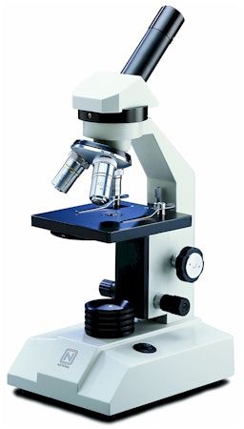Label the three parts of the microscope indicated by the lines.

***Part B 3 marks***

The overall magnification when viewing something under the microscope is the magnifying power of the ocular lens multiplied by the magnifying power of the objective lens. Calculate the total magnification using the following lens combinations (the first one has been done for you)

|  |  |  |  |
| --- | --- | --- | --- |
|  |  |  | **Ocular lens** |
|  |  | **5x** | **10x** |
| **Objective lens** | **4x** |  |  |
|  | **10x** |  |  |
|  | **40x** |  |  |

***Part C 4 marks***

To observe things under the microscope you must follow the following steps closely and in the CORRECT ORDER to ensure you are able to view something easily and without damaging the microscope.

Number the following in **ORDER** from 1 to 8:

|  |  |
| --- | --- |
| Method: |  |
|  | Select the lowest magnification objective lens and using the coarse focusing knob bring the stage to the top. |
|  | Place the slide you wish to view on the stage (making sure the specimen is over the hole in the stage) and secure it using the stage clips. |
|  | Turn the microscope on. |
|  | Take the cover off the microscope and plug the microscope in, but make sure that the power is not turned on yet. |
|  | To magnify the object select the next largest magnification and use the fine focusing knob to bring the image back into focus. |
|  | Look through the objective lens and use the coarse focusing knob to bring the specimen vaguely into focus. |
|  | Use the fine focusing knob to adjust the image until it is in focus. |

***Part D 4 marks***

**Apparatus:**

* microscope
* distilled water
* 1mL teat pipette
* Newspaper pieces of letter ‘e’
* glass coverslip
* flat microscope slide
* forceps

Sometimes we need to make a wet mount: that is we place a specimen on a slide using a solution to fill the space between the slide and coverslip and allow light to pass through the specimen very easily.

**Method:**

* 1. you have been provided with newpaper letter ‘e’
  2. Place it in the centre of the microscope slide. Put one drop of distilled water over the “e”.
  3. Carefully position the coverslip so that one edge touches the water (see figure 1).
  4. Use the forceps to slowly lower the coverslip until it is flat (see figure 2).

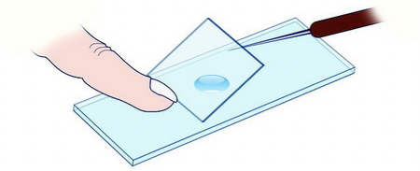



**Put your hand up to show teacher once mounted slide to receive marks. You will be mark on:**

**No bubble: ___/1**

**No spillage:___/1**

**Looking through the microscope at your letter ‘e’ answer the following questions:**

**1.** move the slide to the **left** which direction does the image go? (0.5 mark)

______________________________________________________________________

2. move the slide to the **right** which direction does the image go? (0.5 mark)

______________________________________________________________________

3.move the slide to **up** which direction does the image go? (0.5 mark)

______________________________________________________________________

4.move the slide to **down** left which direction does the image go? (0.5 mark)

______________________________________________________________________

***Part E 3 marks***

To draw things from under the microscope it is important to precisely draw what you see and carefully label the micrograph:

**Using the mini grid draw your letter “e” at each of the three magnifications.**

**(Place your prepared slide on top of the mini grid slide, draw the grid lines and what you see. The grid lines will give the FOV)**

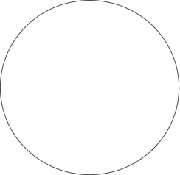**Remember to Label each drawing and indicate the FOV**



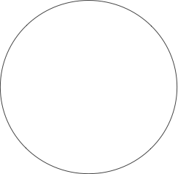

***Part F 6 marks***

**Apparatus:**

* microscope
* forceps
* Minigrd
* Prepare animal cells

**Method part 1 (3 marks );**

1. Place the mini grid on microscope
2. Set the microscope to the lowest magnification- record this in the table.
3. Adjust the minigrid so that it is in the field of view. Make sure that one of the lines of the minigrid lines up with the diameter of the field of view.
4. Count the grid lines – large are 1 mm , small .1mm
5. Record in the table below what the field of view (FOV) size is
6. 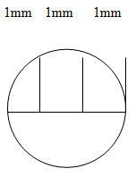Switch to each higher magnification and repeat

|  |  |  |
| --- | --- | --- |
| **Total Magnification** | **FOV - mm** | **FOV –** μ**m (x mm by 1000)** |
|  |  |  |
|  |  |  |
|  |  |  |

Each slide has been stained in order to see the organelles, list three organelle for each of the cells illustrated below in the table provided.

**A**

**B**

**C**

|  |  |  |
| --- | --- | --- |
|  | **ORGANELLES** |  |
| A | B | C |
|  |  |  |
|  |  |  |
|  |  |  |

(3 marks )

***Part G 4 marks***

* 1. Why are stains such as methylene blue used when observing cells under the microscope? (2 marks)

|  |  |  |
| --- | --- | --- |
|  |  |  |
|  |  |  |
|  |  |  |

* 1. What is an advantage of using a wet-mount preparation instead of a dry-mount preparation in the study of living cells? (2 marks)

|  |  |  |
| --- | --- | --- |
|  |  |  |
|  |  |  |
|  |  |  |

**End of Assessment**